* **Install**

npm install react-router-dom

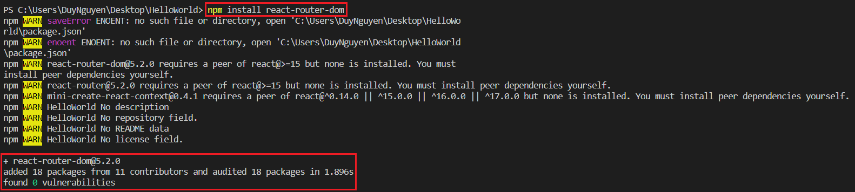

* VD1:

|  |  |  |  |
| --- | --- | --- | --- |
|  |  |  |  |

*Pages*

|  |  |
| --- | --- |
|  |  |

|  |  |  |
| --- | --- | --- |
| *Home page* | *About page* | *PersonList Page* |

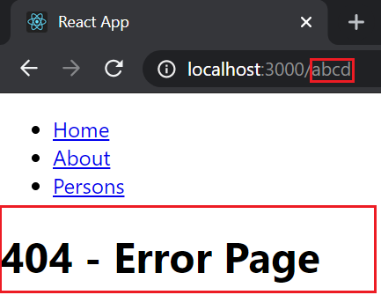

*Error page*

* VD2: Nested route

|  |  |  |  |
| --- | --- | --- | --- |
| *route* | *Trung gian (send match object)* | *match* | Param |

*Nên sử dụng Teamplate String chứ không + string trực tiếp*

|  |  |
| --- | --- |
|  |  |

* Xem thêm các VD

<https://reactrouter.com/web/example/basic>

* **Reference**